**SQL Joins**

# Inner Join

## Fetch the employee’s name and department name they belong to.

**select emp_name, dept_name**

**from JEmployee e**

**join JDepartment d**

**on e.dept_id = d.dept_id;**

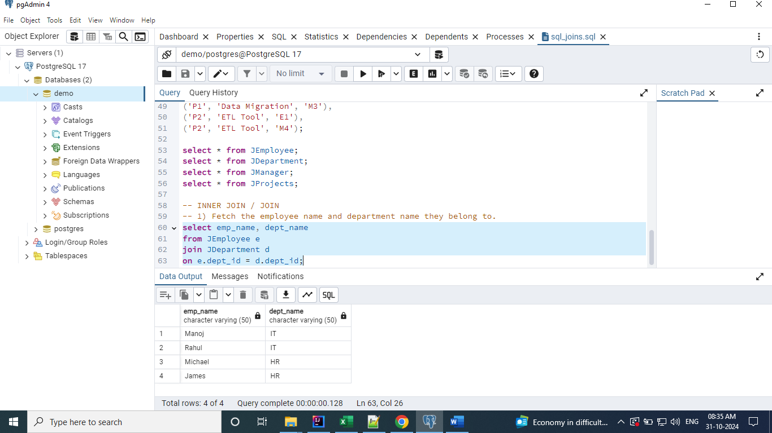

# Left Join

LEFT JOIN [INNER JOIN + Any additional records in the left table]

## Fetch all the employee’s name and their department name they belong to.

**select emp_name, dept_name**

**from JEmployee e**

**left join JDepartment d**

**on e.dept_id = d.dept_id;**

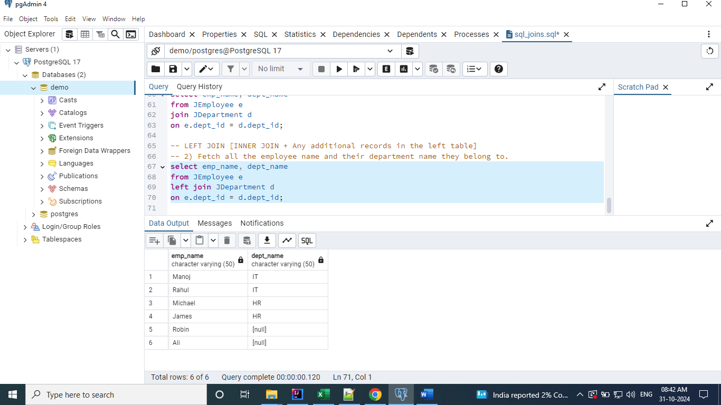

# Right Join

RIGHT JOIN [INNER JOIN + Any additional records in the right table]

## Fetch all the department name and the employee’s name they belong to.

**select emp_name, dept_name**

**from JEmployee e**

**right join JDepartment d**

**on e.dept_id = d.dept_id;**

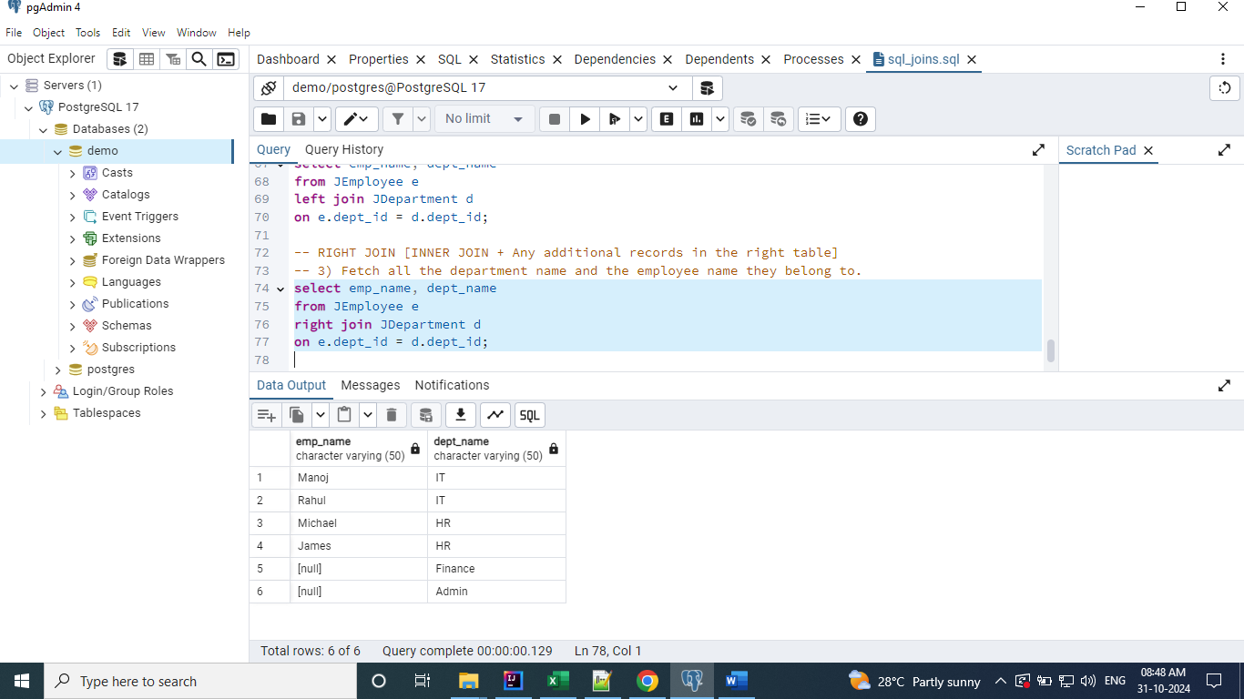

# Inner_Left_Right Join

## Fetch the details of all employees, their manager, their department and the projects they work on.

**select e.emp_name, d.dept_name, m.manager_name, p.project_name**

**from JEmployee e**

**left join JDepartment d on e.dept_id = d.dept_id**

**join JManager m on m.manager_id = e.manager_id**

**left join JProjects p on p.team_member_id = e.emp_id;**

